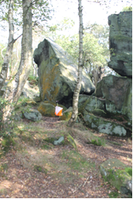
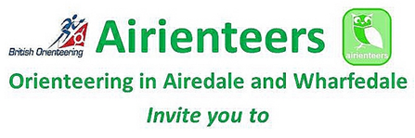
a Night Orienteering Race (Level C) at

Adel Woods (North Leeds)
on
Saturday 15 November 2014

*** First race of the YHOA Night League 2014/15 ***
Location | Adel Woods, North Leeds. Signed from roundabout junction of Leeds Ring Road (A6120) and King Road in Moortown, Leeds at SE 297388
Terrain | Deciduous woodland with good contour, rock & water features, plus extensive path network
Parking & Assembly | Free parking on hard standing car park of The Leodiensian sports club, Crag Lane, Leeds  Postcode = LS17 5PR. Grid Ref = SE 285401
Registration | 17.30 to 18.30 – Entries on the day only
Starts | 18.00 to 19.00 – Start is 200m from registration, Finish is adjacent to registration.
Courses | As per YHOA Night League guidelines:  Enter the course of your choice, but to score maximum points in the Night League, enter:  - Long = for all Men’s classes and Senior Women  - Medium = for all other Women’s classes (Junior, Vet and Super Vet Women)  Full details of the new Night League rules at: www.aire.org.uk/YNL/YNL-2014-15-rules
  Course | Approx. CC standard | Length | Climb
  LONG | Green | 5.4k | 220m
  MEDIUM | Light Green | 4.0k | 175m
  SHORT | Orange | 2.5k | 70m
  INTRODUCTORY | Yellow | 1.7k | 30m
Prices | - Seniors = £6 (£8 for BOF non-members)  - Juniors = £2  Fees are per map. Non-competitive pairs or groups welcome.  - SI Card hire = 50p
Safety | Competitors are responsible for their own safety and take part at their own risk.  Please note the following points where runners should take special care:  - The Long & Medium courses cross a stream, which is usually fairly shallow, but if heavy rain occurs, it may rise. A decision will be made on the day if it remains crossable.  - The Long course crosses an unmanned minor road, where traffic is sparse. Please use the crossing point marked on the map.
Toilets | Inside at the Leodiensian sports club, adjacent to registration
Results | Displayed at Download, and later on Airienteers website www.aire.org.uk
Après-O | Join us for post-race analysis and a drink at a local pub – details on the night!
Officials | Planner: Rob Gatenby  Controller: Steve Webb  Organiser: David Bowman (David.Bowman@ipfin.co.uk) Tel: 0113 225 1649, before 9pm

