 
Airienteers invite you to a top night event
Middleton Woods
Saturday 25th January 2020
A Yorkshire night league event

FINAL DETAILS @ 12.1.20

Venue Nell Bank Outdoor Centre, Denton Road, Ilkley LS29 0DE. GR SE 127 487.

Travel Car – Travel via A65. Coming from the East, TR just before Ben Rhydding traffic lights over the narrow bridge then TL and follow Denton Road West for 1km. Nell Bank is on your right. Coming from the West, TL at the traffic lights in the centre of Ilkley. Cross the River Wharfe then TR and follow the road for 1km. Nell Bank is on your left.

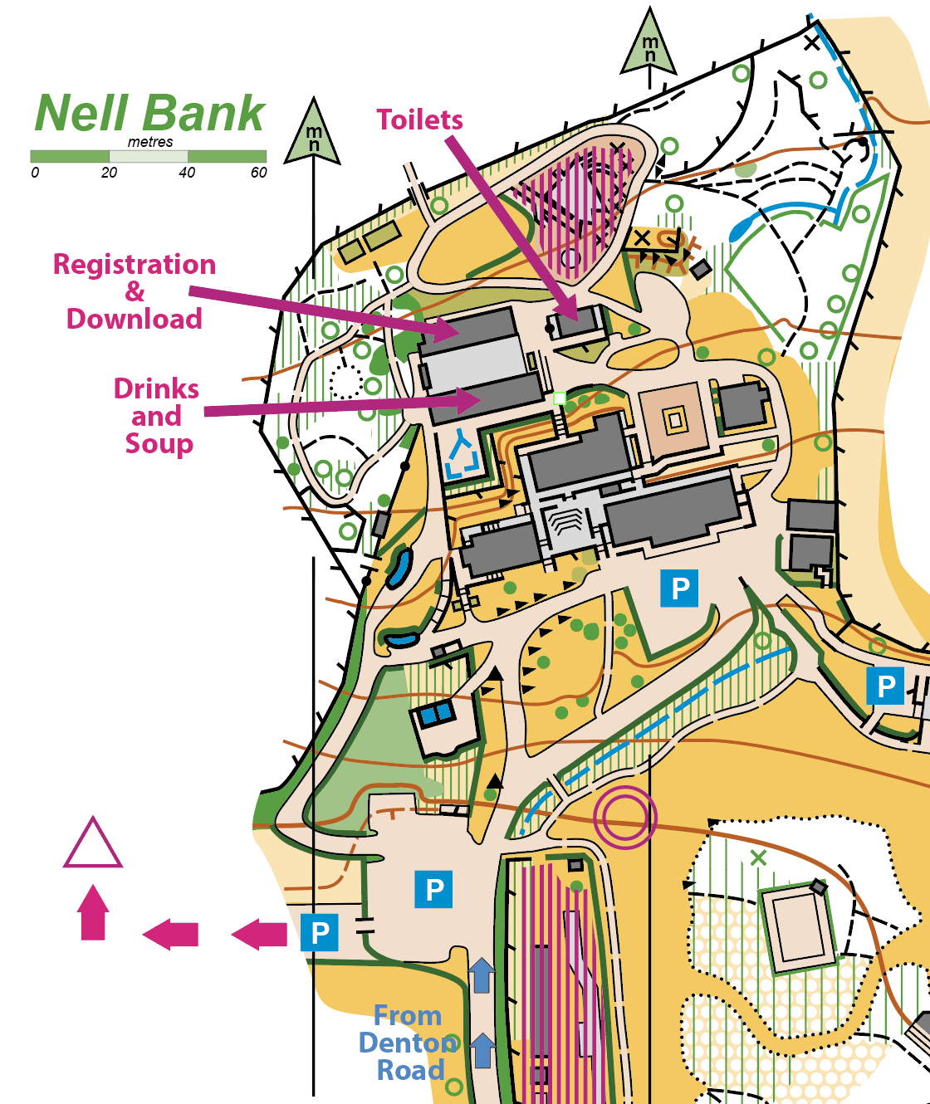
Parking Parking is very limited. Please share transport if you can. You must park as directed and you must not park on the grass in the grounds. Please drive very slowly - the parking is in the competition area. In the unlikely event that we fill all the hard-standing space at Nell Bank, late arrivals will have to park at Ilkley Lido – 800m West of Nell Bank - and walk back along the road to Nell Bank.

Train – Take Wharfedale train line from Leeds or Bradford or X84 bus from Leeds to Ben Rhydding. Go N from the station to the A65 then follow route from East above. It is about 2km from the station to the venue.

Registration In the covered area in the centre of the Nell Bank complex. Register between 5.30pm and 6.15pm. BOF members £8, non-BOF members £10, juniors and students £4. SI card hire £0.50

Courses Courses are open to all, but if you want to get maximum points for the Yorkshire night league, enter the recommended course for your class as shown in the table. All the controls will be SIAC (touch free) enabled but you will need to dib normally at the start and finish.
 | Length | Climb | Map scale | Yorkshire Night League (recommended)
Long | 4.6 | 190 | 7500 | M16-, M18-35, M40-50, M55-60 W18-35
Medium | 3.5 | 100 | 7500 | M65+ W16-, W40-55, W55-60, W65+,
Short | 2.0 | 60 | 7500 | (max score is 90 or 80 depending on age)

Map By Tony Thornley, updated survey 2019. Printed on water resistant paper. The Middleton Woods map is 1:7500 with 5m contours. The long course is in two parts with a map turn over part way round the course. The last parts of the L M and S courses are in Nell Bank grounds and are shown on an inset map at 1:4000 scale.

Starts The start for L, M and S courses is approx. 200m SW of registration and adjacent to the main parking area. Start times from 6.00pm – 6.45pm. Courses close at 8.30pm.

Control descriptions
On the maps with loose CDs in the start lanes. Short course is orange standard with CDs in text not IOF symbols.

Dress Full leg cover - it’s brambly in places. Waterproof jackets may be compulsory on the day - notices displayed at registration and on the website if so.

Terrain South facing wooded slope with brambles and mud and rock in places but mostly runnable. Many minor paths, some of which are indistinct due to fallen leaves. Good contour and rock detail – this is very good night O terrain. Middleton Woods is bisected by a minor road which the L, M and S courses all cross. There is not much traffic, but please take care when crossing. Nell Bank grounds contain many activity areas. Some are marked as out of bounds on the map and must be avoided. Others have boundary ropes which may be crossed, but please take care as some are not very visible at night.

First Aid Basic first aid will be available at Assembly. There is a Minor Injuries Unit at Wharfedale Hospital in Otley, LS21 2LY, approx 8km to the east of Ilkley. The nearest A&E unit is at Airedale Hospital, Steeton, BD20 6DT. Directions to both available at enquiries.

Safety Competitors take part at their own risk and are responsible for their own safety. The terrain is not exposed, but please dress appropriately for the conditions and time of year. Whistles should be carried. If travelling alone please leave car keys at Enquiries and leave a contact number as a safety check. The safety bearing is head south to Denton Road.

Results Will be available in assembly and posted asap on the Aire website www.aire.org.uk

Facilities Hot drinks and soup kindly provided by Friends of Nell Bank from the café area adjacent to registration and download. Please support this facility. Toilets near registration. Please take muddy shoes off in the toilets and in the covered areas.

Cancellation: In the event of cancellation due to bad weather, details will be posted on the Aire website. Information can also be obtained by phoning the organiser. In the event of cancellation Aire reserve the right to retain part of the entry fees to fund any unrecoverable costs.

Officials Planner Frank Kew AIRE. 0770 4260953
Controller Tony Thornley, AIRE 0777 1843255
Organiser David Alcock AIRE 07989 563588 before 10pm please. secretary@aire.org.uk

Thanks to Bradford MDC and Nell Bank Centre (Dan Goodey).

