Wednesday 12 December 2018

CHRISTMAS SOCIAL in

FLYING DUCK, ILKLEY

preceded by

ILKLEY STREETS NIGHT SCORE ORIENTEERING EVENT

The final event in Airienteers’ Autumn Night Score Orienteering Series

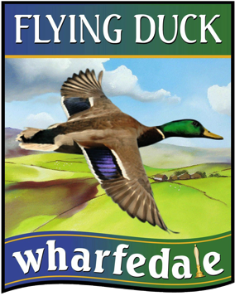
All welcome! Details for the Ilkley Streets Night Score Event are here

In a Score event you do as much or as little as you like, taking any route between any controls. Some controls are worth more points than others and penalties apply for each minute late back.

Registration from 1830 - Briefing 1855 – MASS START 1900
Mainly pavements and paths so road shoes are fine
Don’t forget headtorch, pen and a time-piece!

The map will be A3 size, 1:5,500 scale, printed on waterproof paper and with control descriptions, clues and answers printed on the reverse.

Please don’t forget to calculate your score on the night and note this on the registration sheet when you sign-out - and before you take your map home!

FOOD, BEER, PRIZE-GIVING & SOCIAL

After the event, runners and non-runners are all very welcome to join us upstairs in the Flying Duck, Ilkley’s community pub nearby on Church Street.

Veggie and meaty chillis with chips and sour cream will be available for £10pp

If poss, please let me know if you are eating so I can guide the pub. Thanks

Organiser – Rob King – thekingz@blueyonder.co.uk - 07954 996848

ILKLEY – LEEDS – BRADFORD train info
ILKLEY – OTLEY – LEEDS X84 bus info

