**BRADFORD CITY RACE SUNDAY 20 JULY 2025**

Welcome to day 2 of Airienteers’ Bradford Urban Weekend. This is a genuine city centre race; our event arena is in the recently re-landscaped Norfolk Gardens next to City Hall and courses include the pedestrianised city centre, commercial and civic quarters including Little Germany and some edge of centre residential areas.

**Arena**

Registration/Enquiries/Download will be in tents adjacent to the pedestrianised section of Hall Ings just south of City Hall. There is some bench seating available alongside at the “Tower of Now” sculpture and a tent for clothing dump.

**Parking/Directions**

Parking is available at The Broadway shopping centre multi-storey and the Leisure Exchange and other public car parks. Further afield the on street car parking is also subject to charges on a Sunday.

We encourage you to use public transport: Bradford Interchange bus and train station is only 250m from the arena and Forster Square station is 650m away.

The arena is at BD1 5SD w3w: half.void.values

From Bradford Interchange go downhill on Bridge Street and turn left on Hall Ings in front of the Bradford Hotel, 100m to arena.

From Bradford Forster Square follow signs (and studs in pavement) for Bradford Interchange to Bridge Street/Hall Ings junction. 100m to arena beyond the Bradford Hotel.

From The Broadway Centre follow Broadway to Bridge Street and turn left to Bridge Street/Hall Ings junction. 100m to arena beyond the Bradford Hotel.

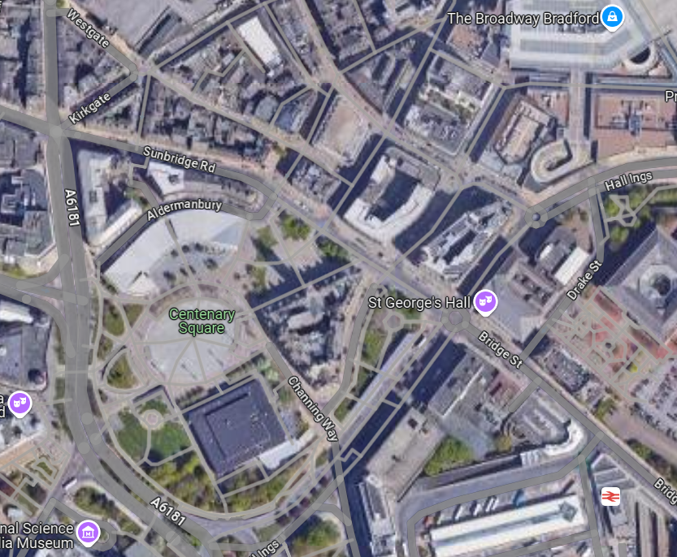

Bradford Interchange

Bradford Hotel

Registration/Enquiries/Download

City Hall

Google maps

**Toilets/Refreshments**

There are free toilets at The Broadway shopping centre and at Bradford Interchange. There are also free toilets at City Pavilion but that is within the competition area so please stay away from there until after your run.

We are not providing any water or other refreshments; you are responsible for your own hydration so please bring sufficient water, particularly if the forecast is for hot weather. There are plenty of catering outlets in the city centre including a food court at The Broadway, The Cake ‘Ole café at City Pavilion serves huge portions of cake, and at the coffee shop in Waterstones (housed in the former Wool Market) you can admire the magnificent Victorian architecture.

**Registration/Start Times**

Registration from 10:00 to 12:00 noon

Start times from 10:30 to 12:30

Courses close at 14:30

There is a single start for all courses 175m from assembly. Follow taped route past City Hall. Pre-entries have chosen a start window and the start officials will give priority to competitors who are ready and wanting to start in their selected window.

**Entry on the day**

Senior BO members: £12 on courses 1 to 4, £7 on courses 5 to 7

£2 supplement for non-BO members

All Juniors and students: £5 on courses 1 to 6

Juniors on course 7: no charge

Dibber hire is £1 apart from Juniors on courses 5 & 7. If you are running course 1 or 2 and need a dibber with greater than 30 control capacity you can hire one.

**Course Information**

|  |  |  |  |  |  |  |
| --- | --- | --- | --- | --- | --- | --- |
| Course | Technical difficulty | Straight line distance | Optimal running distance | Climb m | Classes |  |
| 1 | TD3 | 7.6k | 9.7k | 168 | MO, MV, WO | More than 30 controls |
| 2 | TD3 | 6.2k | 8.0k | 123 | MSV, WV | More than 30 controls |
| 3 | TD3 | 5.1k | 6.3k | 95 | MUV, WSV |  |
| 4 | TD3 | 3.8k | 4.5k | 63 | MHV, WUV, WHV |  |
| 5 | TD3 | 2.0k | 2.6k | 15 |  | Accessible course |
| 6 | TD3 | 2.2k | 2.5k | 25 | MJ, WJ | Only crosses quieter roads |
| 7 | TD2 | 1.3k | 1.5k | 15 | MYJ, WYJ | Uses pedestrianised area only |

O = 18-35, V = 40+, SV = 55+, HV = 65+, UV = 75+, J = 16-, YJ = 12-

**Map**

Scale 1:4,000, 2.5m contours, surveyed and drawn by Chris Burden including 2025 updates.

**Terrain and notes for competitors**

City centre central business district and edge of centre residential areas. Please respect out of bounds including private land and ornamental flower beds shown as olive green, particularly in the recently landscaped and re-planted Norfolk Gardens near the finish.

All controls are SIAC enabled but you will need to punch/dib the start and finish controls. Controls are generally grippled to street furniture, but to improve access some SI boxes will be on stakes and the common final control and the finish will be on trestles. The run in to the finish will have intermittent rather than continuous taping, but is clearly visible from the final control.

Courses 1 to 4 include a 2 minute timed out road crossing. This is at a light controlled pedestrian crossing. Make sure you punch the controls on both sides of the road and cross safely.

Please follow the normal protocols for urban orienteering: pass wide around blind corners, be aware of and courteous to other competitors, pedestrians, cyclists and road traffic and don’t take risks when crossing roads.

We understand that there is likely to be some sort of dance related event in the City Park/Centenary Square on Sunday. We don’t have details of the exact extent and nature of the event but will establish this on the morning and will provide guidance at the start if it appears there is any impact on our courses.

**Safety**

A comprehensive risk assessment has been carried out by the organiser, but participants take part at their own risk and are responsible for their own safety during the event.

**Insurance**

British Orienteering provides Public Liability insurance cover for all individuals taking part in our organised events and activities.

**Officials**

Planner: Jack Smith AIRE

Organiser: Steve Webb AIRE saraandsteve1ATbtinternet.com 07944 092195

Controller: David Alcock AIRE