Colton,Leeds. 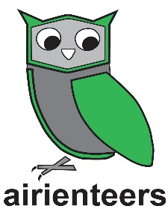

Directions and Parking: Use Colton Retail Shopping Centre Car Park LS15 9JA – maximum stay 4 hours. What three words /// cycles.lung.even

Public Transport:Number of buses to and from Leeds and along the Ring Road pass the Colton Retail Park 9, 9A, 19, 19A, 21, 22, X26,163,164 and 166.

The Area: Colton is an interesting urban area with modern housing separated by grassed areas with plenty of snickets. To the north west is an older, more intricate housing estate with many snickets, garages and parking areas. A good urban challenge.

Course:Two courses – Long 5.5km (21 controls) and Medium 3.9km (13 controls)

Map: Urban map at 1:5000 contour interval 2.5 m. Download your map to take with you.

We recommend running with the paper map and stowing your phone.

We suggest you are 100% ready to run when you switch the app on so as not to utilise any of your precious time! If you do have a false start just end your run and start again.

Important Note;Do not go near the finish area en route between any 2 controls. The app will likely finish your run - which would be very frustrating. The courses are designed to make going near the finish midway through the course a very poor route choice

Maprun: The event will use the free Maprun F app to track and verify your run and register your time. If you have not used the App before please see our full information on our website page https://www.aire.org.uk/info/maprun; You need to download the course/s you want to run whilst you have internet access (eg at home). And you need to print yourself a copy of the paper map which is also on the website.

Where to find this course on the app: Open the app Select Event UK Folder Aire Valley Folder Lockdown Series Colton Long / Colton Medium Download

Ready to run press “Go to Start” Ensure your GPS is on by waiting to see red dot. Go to the Start point your time starts with the beep as you pass.

