Little London – 23rd June – Planner’s Notes
Firstly, a big thank you to Richard for the brand-new map – I’m sure you’ll all agree that Little London is a cracking new area (that we barely scratched the surface of!). I was spoilt for choice with housing estate but tried to plan courses with a mixture of route choice legs and control picks, and a 15-minute winning time for the speediest. It was very entertaining watching you all start & have to immediately deliberate over the route choice to number 1!
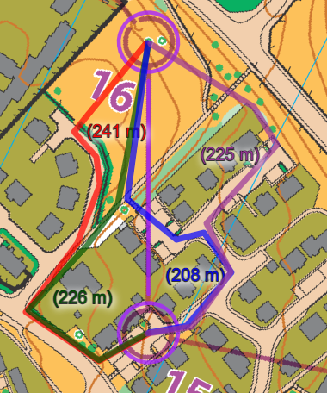
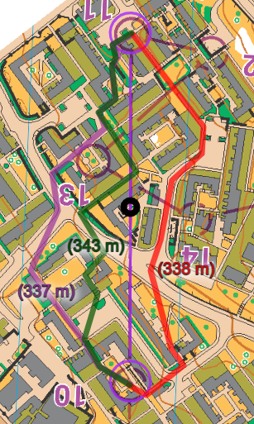
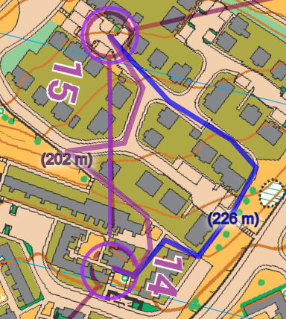
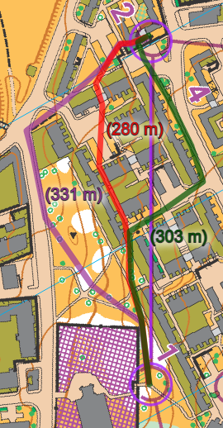
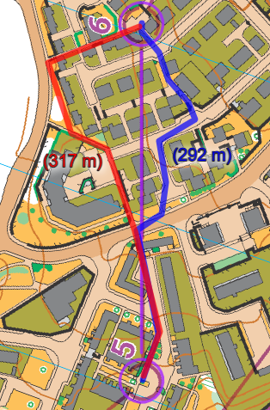
Did you find the fastest routes?
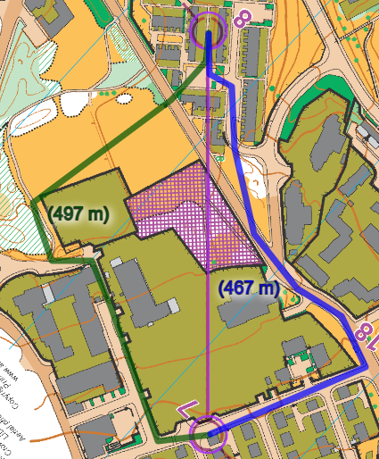
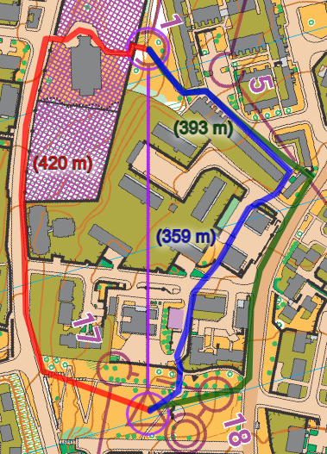

Thank you to David for sorting the SI and payments on the night, and to Janet & Jonathan for helping me to collect controls & get home quickly – very much appreciated

