Coaching at Micklefield – a great start for AIRE juniors in 2023
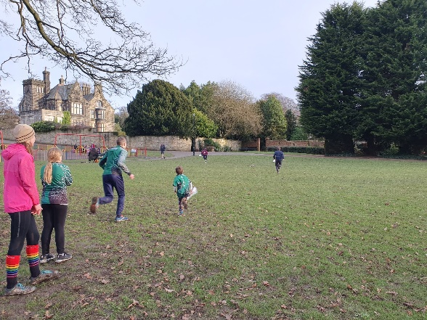
18 juniors ages 2 – 16 joined our coaching session at Micklefield Park Rawdon in January. We began by leading a map walk to find controls on a line and guess their description. Juniors were encouraged to fold & thumb their map to keep in touch with where they were.
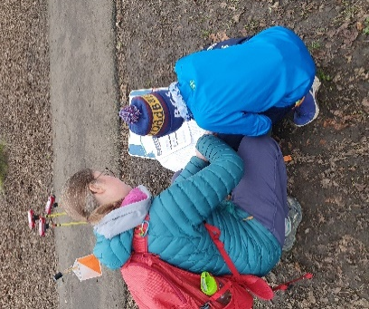
Then there were 2 separate lines to follow in pairs with the same aims to spot controls and describe their position. After that we progressed to exercises where each pair took it in turns to navigate to a control. The follower has to watch where they are going and locate themselves on the map once the control is found so they can then lead the way to the next control. We encouraged the pairs to think out loud so that they would each learn from the others navigation techniques.
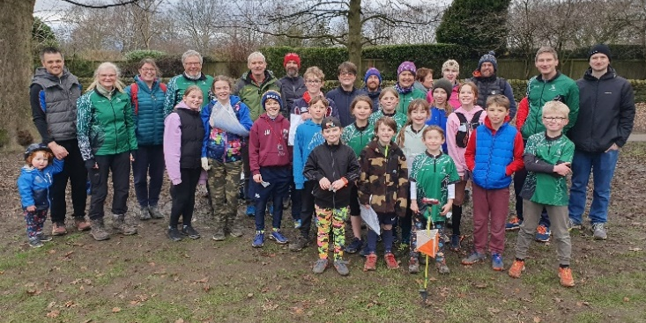
We finished off with 5 teams competing in a relay with a moving control! Each team member had to run to one of 6 controls and then had to find the moving control before coming back to base. This was made more tricky by the hedge that obscured the view of the moving control on its circuit around the park! The fast and furious race ended with some close finishing times. Well done everyone!
Feedback suggested that the line exercises were popular and most juniors enjoyed the relay. Thank you to David, Joyce and Rob for helping and for all the parents brought Juniors on fairly short notice. Photos courtesy of Rosie! Lindsey King

