Juniaires May 2023

Dibber the owl is seriously impressed at how much AIRE juniors have achieved already in 2023!

Coaching sessions, club events and national & international competitions have attracted lots of participants. Since January more and more juniors in green AIRE tops can be found improving their navigation skills or competing in races and relays.

Coaching
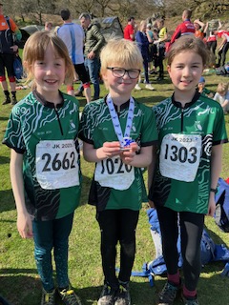
Micklefield Park coaching session attracted 18 juniors ages 2 and 16 and lots of parents. We practiced careful following of lines, orientation and thumbing the map and a fun relay with a moving control.

At Horsforth Hall Park a much smaller group enjoyed finding controls using photo clues and developing their knowledge of different map symbols.

Since then coaching exercises have been offered at the Saturday introductory/junior events and ar Roberts Park juniors had a chance to focus on route choice to and from controls as well as running the various courses on offer. At Littlemoor Park Queensbury accurate map orientation at speed was practiced around a small maze.

Events
Flasby Fell - 17 AIRE juniors ran courses over the open fellside at our regional event in February. Lots of fun was had by all ages racing around the string course in the fastest time! Ross Carson took 4.04 for the boys and Bethan Buckley 4.06 for the girls. Sebastian spotted the off string short cuts!

Compass Sport Cup heat- We are very grateful to families with juniors driving a long way to Northumberland in March to compete against West Cumberland and CLOK. All 5 juniors Kate, Katie, Megan, Henry and James score points for the team result. This year we were beaten by WCOC which does save us all a long journey in the opposite direction for a final.
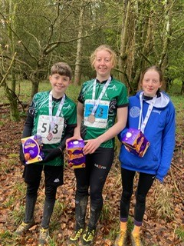
British Championships – Enough juniors travelled south to make up a team for a junior ad hoc relay. Katie, Bethan and Henry came home with a bronze medal for AIRE making the trip well worthwhile - well done!

JK 2023 - A record number of juniors (20) and families participating in the annual Easter festival this year in south Lake District. For some it was their first taste of a large international event. 3 of the days’ races were selection opportunities for international summer competitions.

Some of results (apologies for any mistakes or omissions) in A-Z order:
Alethea - W12 - sprint 10th silver, middle 13th, long 11th
Alfie - M10 - spring 12th bronze, white courses
Bethan - W14 sprint 11th W14A middle 16th silver, long 16th bronze
Charlie - M10 - 2nd sprint, M10A middle 1st - both championship standard
Charlotte - W12 sprint 8th silver, W12A middle 8th bronze, long 12th
Emily - W18Elite - sprint 4th, middle 6th, long 5th- all championship standard
Ewen - M16A - middle 37th, long 21st bronze
George - M10 sprint 13th M10A middle and long shadowed

Henry - M16 sprint 27th silver, M16A middle 25th bronze, long 29th bronze
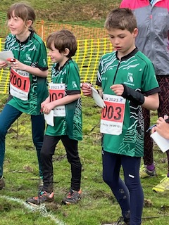
Isobel - white courses
Jack - M16 sprint 44th, M16B 3rd silver, long 5th
James - M16 sprint 36th bronze, M16A middle 36th, long 37th
Joby - M10 sprint 11th bronze, M10A non comp middle, long 7th bronze
Katie - W16 sprint 8th championship, W16A middle 12th gold, long 20th silver
Lauren - white courses
Megan - W16 - 31st silver, W16A middle 32nd
Oscar - Novice sprint then white courses
Penny- W10 sprint 2nd championship, W10A middle 4th, long 2nd ……..
Sebastian - M10 sprint 9th bronze and white courses
Theo - Novice sprint then white courses

The best overall results were Emily 4th on W18E, Jack 2nd on M16B and Penny 2nd on W10A. Emily’s results qualified her for international selections this summer – Congratulations Emily!

My favourite moment was watching our 3 mini relay teams on the start line and watching all 9 race down the hill at the end of their courses- Penny, Charlie, Alethea, Joby, Alfie, Sebastian, Theo, Oscar and Isobel. Top marks goes to Helen Alcock for shadowing multiple legs!

Relay running needs confidence and care. Racing as a team is a great skill to learn when young and 2 of our teams participated as shadowed non-competitive teams which will be great preparation for future races. Also, mental strength and skills develop from making mistakes which leads to better performances in the future.

One lesson for us to learn as a club is that we should help prepare newer members for larger events by explaining things like the need to allow plenty of time to reach starts, accessing and reading the final details and noting the stricter rules that apply to big competitions.

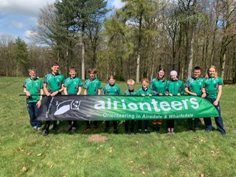
Yvette Baker Trophy - 11 AIRE juniors travelled to Lincolnshire by minibus on 16th April to compete in the annual junior inter club competition in April. There were 8 courses: yellow to green for boys and girls. As usual we were competing against South Yorkshire who brought 40 juniors to our 11. However, only 9 from each club count and so although they won 7 of the 8 classes we were only 20 points behind them at the end. Well done to Ewen for winning light green for us! It was great to have parents along too who all competed. The return trip was lively! Thanks to the Club for paying junior entries and the minibus hire and David Alcock for driving.

The Yvette Baker final is on Sunday 9th July near Doncaster so please put book this date as we need at least 9 runners and Bradford Grammar School have already started their summer holidays by then which may reduce numbers.

Lindsey King- Coach

