NOW TAKING ORDERS FOR NEW CLUB KIT
The club is placing orders for an additional stock of club O tops for the junior loan scheme. Club members who would like to purchase their own O top or jacket are welcome to place an order with us and we’ll add these to our bulk order for club stock. The supplier is Bryzos and in their brochure the garments available in the AIRE design are called “race shirts” (O-tops) and “representative jackets”. You’ll have seen clubmates proudly sporting these stylish garments at events, but for the avoidance of doubt this is what they look like.
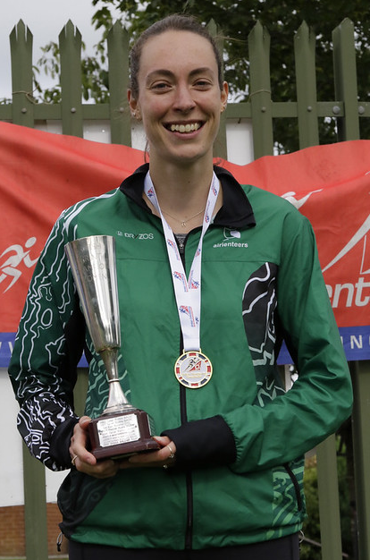
O-top Jacket
The cost of the O top is €28.00 for standard sizes €22.40 for Kids’ sizes. The jacket is €42.00 for standard sizes, €33.60 for Kids’ sizes. Final price to you will depend on exchange rate, VAT at 20%, delivery and bank charges.
If you would like to place an order please email me at saraandsteve1@btinternet.com with “AIRE Club Kit” as the title. You’ll need to let me know the garment type and style (O-top/Jacket, Men/Women/Kids) and size: do please double check the size you want in accordance with these sizing guides: https://www.bryzosport.com/size-guide
Please let me know your orders by 11 April so we can get our order in; we will collect your payments on delivery. Please contact Lindsey direct lindseyking49@hotmail.co.uk if you would like to participate in the O top loan scheme for juniors so she can co-ordinate numbers.

Steve Webb

