Mini Relay Stars at JK2022!
Congratulations to Charlie, Penny, Joby and Alfie - AIRE’s first mini relay team for a few years!
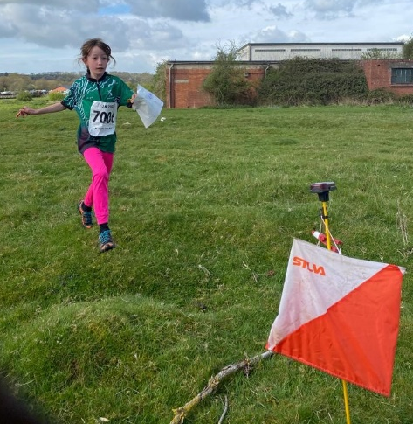
On Easter Monday the JK2022 relays were held at Caerwent Barracks near Chepstow. Amazingly the sun was still shining when Charlie stood on the start line of the junior mini relay at 10 am – Memories of Joe Woodley and Gemma King racing on the same area 15 years earlier …
We must have had the youngest team in the race (all well under 10). Many other teams had juniors up to 12 years old. We were also the only team with 2 runners on last leg as Alfie was super keen to compete too!
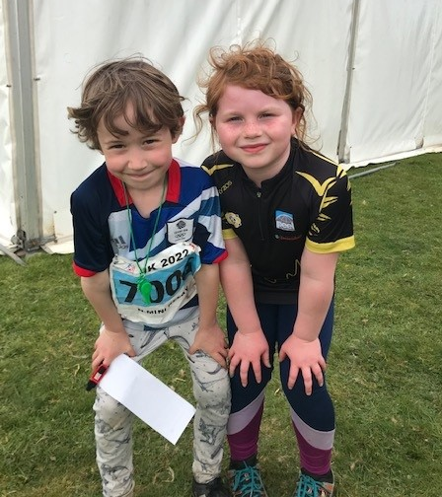
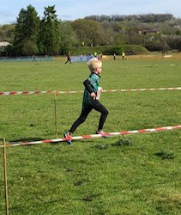
It was exciting to watch each junior run in into the arena in front of crowds to enthusiastic applause. I am sure it was also a great relief to their parents to see each cross the finish line. Joby’s map seemed to have gone missing somewhere along the route but he had used his initiative to team up with an SYO runner and they were happily running together along the finish funnel!
We may not have achieved a position in the results but let’s hope that this will be the first of many more JK relay runs for these enthusiastic young AIRE juniors!
Next year’s JK is much more local in the south Lake District so book the Easter weekend in your diary and come and join in a great festival of orienteering

JK2022 -individual results
6 AIRE juniors came to JK2022 over Easter weekend in South Wales. Here are the results- Well done to everyone!
 | Jack | Charlotte | Charlie | Alfie | Penny | Joby
Day 1 | 36th M12 | 14th W10 | - | - | 5th W10 | 5th M10
Day 2 | 7th M14B | 1st W12B | 2nd M10B | - | 4th W10B | 4th M10B
Day 3 | 4th M14B | 1st W12B | 1st M10B | 5th White | 2nd W 10B | 2nd M10B
overall | 5th M14B | 1st W12B | 1st M10B | - | 3rd W10B | 2nd M10B

