The Yvette Baker Trophy

I thought that competing in the Yvette Baker trophy was a fun, interesting experience, especially as we were competing as a team. The National Arboretum was very pretty and nice to orienteer in, but I found that it wasn’t really suited to more difficult courses, as there weren’t really any interesting terrain features or places to hide controls. My course itself wasn’t as difficult as I had thought it would be, although some parts of it were still quite challenging, especially in areas where there was a large amount of undergrowth to fight through, as this made getting to the controls quite a lot more difficult. This is the first time I have used RouteGadget and it has helped me see where I’ve made mistakes and could have made better route choices.

My route & course:
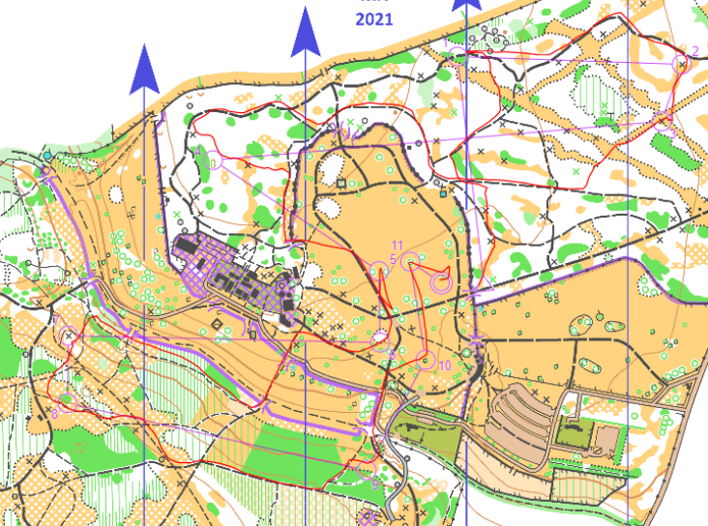
James Woodham

