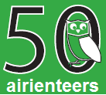  

[Final Details Leeds City Race](https://www.aire.org.uk/images/40807482643_1a69c51f57_c.jpg" \o "click for larger version)

[Sun 08 September, 2019](https://www.aire.org.uk/images/40807482643_1a69c51f57_c.jpg" \o "click for larger version)

Welcome to the first City Race in Leeds, and a UK and Yorkshire Urban league event. The

Event Centre is in the Edge Sports Complex, Willow Terrace Road, Leeds University.

* **Grid Ref:** SE295343
* **Postcode:** LS2 3AE
* [Google Map](https://www.google.com/maps/place/53.8045,-1.5533/@53.8045,-1.5533,12z)
* [Streetmap (OS 50k)](https://www.streetmap.co.uk/loc/53.8045,-1.5533&z=120)

Start – 200m from registration. Finish – adjacent to registration.

**Travel to the event**

Please use public transport if possible. It is just over 1km and 15 minutes’ walk to the Event Centre from Leeds train station and 1.6k, 22 minutes’ walk from Leeds bus station. Competitors will cross the competition area and must follow a set route from the train/bus station:

From Leeds train station**:***North on Park Row; West along The Headrow; North on Calverley Street; at roundabout Willow Terrace Road (goes over A58).*

From Leeds bus station: *West on George St; North on Vicar Lane; West along The Headrow; North on Calverley Street; at roundabout Willow Terrace Road.*

Alternatively, City Centre First Bus No. 5 from Bishopsgate drops off outside the Leeds Infirmary A & E department with a short walk along Willow Terrace Road to the Event Centre.

**Out of Bounds:**All routes to the Event Centre from the South (Clarendon Way) through to the West (Mount Preston Street) to the North (Lifton Place and LUU Precinct). See map below.

**Parking**

Limited parking at The Edge car park (accessed via Willow Terrace Road) for helpers, competitors with children and hypervets. If you are in one of these categories, you can collect a code from the enquiries desk at registration for 3 hours free parking. You can stay longer but you will have to pay for any excess time (code/payment entered on exit).

All other competitors should use nearby roads - e.g. Clarendon Road (west of University) has mainly unrestricted parking on Sundays, as do the streets leading west off it. Do not enter the university from the west side- If parked on the west side you can either head north along Clarendon Road to Woodhouse Lane and enter via Parkinson steps (upper red arrow), or head south on Clarendon Road and cross the A58 by the bridge to Great George Street, then Calverley Street to Willow Terrace(lower red arrow).

There is a multi-storey car park in Woodhouse Lane. Please do not use the Leeds Hospital multi-storey car park. Please car share if possible.

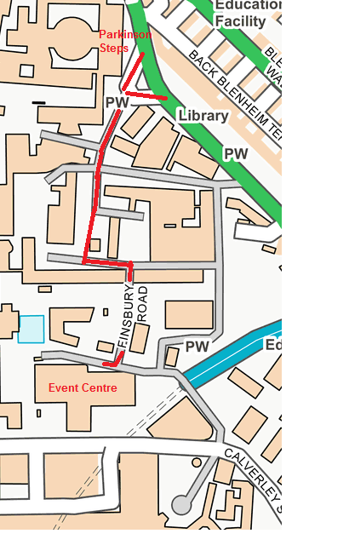Route from Parkinson steps toEdge event centre: *South on Cavendish Road; at Lodge Street continue South on Cavendish Road; then East and South onto Finsbury Road; arrive Willow Terrace Road.*

**Registration**

Registration, download, enquiries, and first aid are on the ground floor of the Edge, assembly is on the lower ground level, all accessed via a side entrance off Willow Terrace Road which will be clearly marked. (No access for orienteers through main entrance into the Edge). You may use any of the toilet and shower facilities in the Edge, and there are lockers available (£1 refundable) or belongings can be left in assembly at owners’ risk. None of the cafés within the University will be open but there are vending machines selling hot and cold drinks and snacks near assembly.

**String course -** there will be a string course within the University grounds 10.00-12.00

**Pre-entry** via [fabian4](http://www.fabian4.co.uk/)until midnight on Sunday 1st September. Please pre-enter to ensure a map for the course of your choice. This will help us order the correct number of maps.

£8 for BO member Seniors; £10 for non-member Seniors; £4.00 for Juniors and Students.Yellow Course only: Seniors £4 Juniors free

There is a £1 discount for competitors who enter both Saturday (Chasing Sprint at Colton and Temple Newsam) and Sunday (Leeds Urban Race) together.

**EOD –**subject to map availability -£10.00 for BO member Seniors; £12 for non-member Seniors; £4 for Juniors and Students. Yellow course only: Seniors £4 Juniors Free

Registration opens at 09.30 and closes at 11.00

**SI Hire** on the day only, 50p.

Traditional SI cards only will be available for hire - unfortunately we are not able to offer SIAC cards for hire. A charge of £30 will be made for lost or non-returned hire SI cards.

**Starts** are from 10.00 - 12.00. Courses close at 13.30.

**Electronic Punching**

Controls will be enabled for contactless punching with SIACs except Start and Finish

which will need to be punched by all competitors.

A SIAC battery test box will be at the Start and final SIAC test will be available at -1.

***It is the competitor’s responsibility to ensure that their SIcard has registered at the control.***

**Course Information**

**Course 1**: Men Open (M18- M35 inclusive)

**Course 2**: Men Vet (M40+): Women Open (W18-W35 inclusive)

**Course 3**: Men Supervet (M55+): Women Vet (W40+)

**Course 4**: Men Ultravet (M65+): Women Supervet (W55+)

**Course 5**: Men Hypervet (M75+): Women Ultravet (W65+): Women Hypervet (W75+)

**Course 6**: Junior Men (M16-): Junior Women (W16-)

**Course 7**: Young Junior Men (M12-): Young Junior Women (W12-)

Provisional course details below subject to final controlling and safety checks.

|  |  |  |  |  |
| --- | --- | --- | --- | --- |
| **Course** | **Length (Straight line)** | **Climb (Estimated)** | **Controls** | **Expected distance run (Estimated)** |
| 1 | 8.2km | 100m | 32 * | 10.7km |
| 2 | 7.5km | 75m | 32 * | 9.4km |
| 3 | 6.4km | 70m | 27 | 7.9km |
| 4 | 5.1km | 60m | 18 | 6.2km |
| 5 | 4.0km | 50m | 18 | 4.8km |
| 6 | 3.2km | 65m | 18 | 4.0km |
| 7^ | 1.7km | 20m | 17 | 1.9km |

*\* modern 7 series or above dibber required as more than 30 controls. If you have an older style dibber (or have a hired dibber) you will get an overall time but will not get split times for the last 2 controls.*

^ course 7 contains a butterfly loop (controls 1-6).

You may enter any course you wish, but to be competitive in the UK and Yorkshire Urban League you need to enter the course listed for your class.

Juniors aged under 16 on the day will only be allowed, due to safety and insurance conditions, on the Light Green (6) and Yellow (7) Courses.

**Map**: Updated 2019 surveying and cartography by Richard Foster (City) and Chris Burden (University). Additional campus and surrounding areas have been added to the [2018 routegadget map](https://www.aire.routegadget.co.uk/rg2/#146).

1:4000 5m contours (not 2.5m as per ISSOM 2017).



Early adoption of ISSOM 2019 multi-level symbol.

**Control descriptions** will be on the map and loose in the start lanes.

**Route to start**

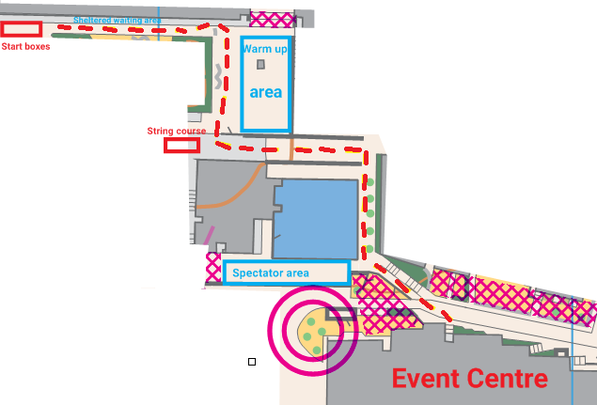

**Terrain Description**

Late summer fast running along paths, roads, tracks, across bridges, down ginnels/snickets, around urban furniture, through city park squares, along terraces and backs, in between office blocks, across retail centres and streets and the University campus

Take in the sights of Leeds including the City Square, Leeds Town Hall, Millennium Square, University Colleges and Campuses.

**Safety**

The junior courses are entirely within the University grounds which will be mostly traffic free, but juniors should be warned that there may be some slow moving traffic on the campus.

There are some building works on campus but courses avoid these.

Roads in the city centre may be busy - take care when crossing them, and be considerate to pedestrians, reduce speed at corners and take them wide to avoid collisions.

**Dog restrictions**

No dogs in The Edge.

**Post event things to do**

The Edge indoor swimming pool will be open to the public from 12.15 (£6 for adults).

Socialise at the [Leeds International Beer festival](http://www.leedsbeer.com/) -Town Hall on the Headrow.

Visit the Leeds art gallery and adjacent sculpture gallery (free entry, open 11.00-15.00) also on the Headrow. The art gallery café, just inside the main entrance, is in a beautiful tiled hall and worth a coffee at least.

**Contacts / Officials**

**Organiser :** Sue Stevens 07463796598 sue@nebstone.co.uk

**Planner:** Robert Gatenby

**Controller :** Chris Mackenzie

**Thanks** to Will Patterson for his help in gaining permission to hold the event in Leeds University and thanks to the University staff for allowing us to use their premises.

**Other Important Information**

**Safety and Risk:** A comprehensive risk assessment will have been carried out by the organiser, but participants take part at their own risk and are responsible for their own safety during the event.

**Insurance:** Please note that if you have competed in three orienteering events registered with British Orienteering and not joined an orienteering club which is a member of British Orienteering then you are not covered by our public liability insurance

**Privacy:** when entering our events your name may appear in the results section of this website or in newspaper reports. Read our [data protection](https://www.aire.org.uk/info/data-protection) page to see how we look after your personal data.

© 2019 Airienteers